Student Assessment Submission and Declaration
When submitting evidence for assessment, each student must sign a declaration confirming that the work is their own.
Student name:adel shurab 21023153 |  | Assessor name: Balqees Aldabaibeh
Issue date (1St Submission):  18/4/2023 | Submission date (1St Submission):  13/6/2023 |  | Submitted on:
In case of resubmission
Issue date (1St Submission):  21/6/2023 | Submission date (1St Submission):  23/6/2023 |  | Submitted on:
Programme: Higher National Diploma in computing
Assignment number and title: 1 Design and implement complex data structures and algorithms

Task 1 :

1:1:
Here is a class diagram that represents the classes and their relationships as described:
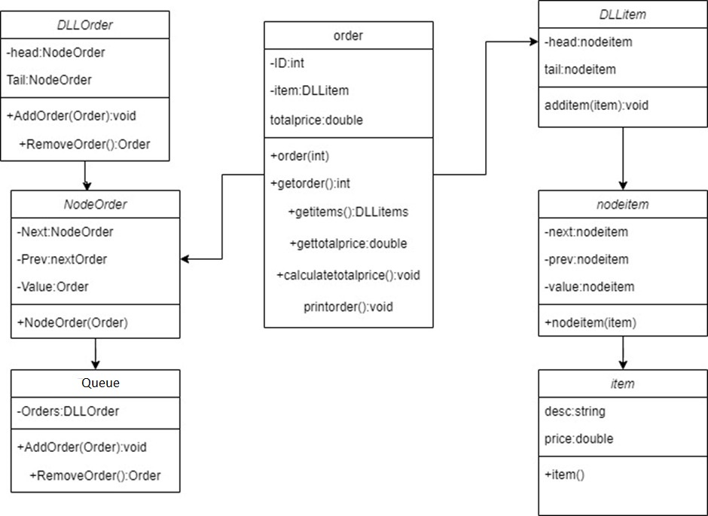

In a class diagram, each class is represented by a rectangle. Variables for each class are arranged inside the rectangle, preceded by a minus sign to indicate that they are private. Each class's integrations are arranged below the attributes, preceded by a plus sign to indicate that they are generic.

The order class contains the order id, a set of items, and the total price. It has processes to calculate the total price based on the items and print the order.

The item category contains a description and a price.

The Queue class represents a queue of orders and contains a reference to the DLLOrder class, which does double duty and is the operations for adding and removing an order to the queue.

The DLLOrder class represents a node in the doubly linked list of orders. It contains references to the next and previous nodes and carries a request. It has processes to add an order or remove an order from the list.

The DLLItems class represents a node in the list of elements. It contains references to the next and previous nodes and carries a . It has a process for adding an item to the list.

Even though the classes DLLOrder and DLLItems are nodes in a doubly linked list and share a similar syntax, they have different functions. While the DLLItems class is used to hold elements, the DLLOrder class was created expressly to store orders.

1:2:

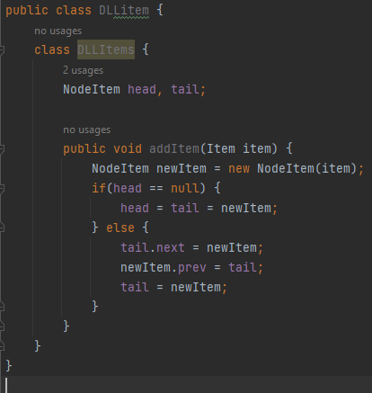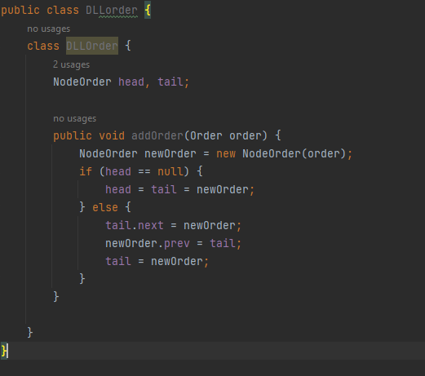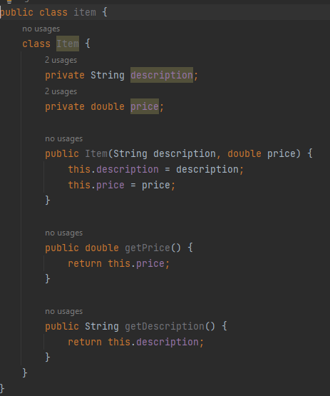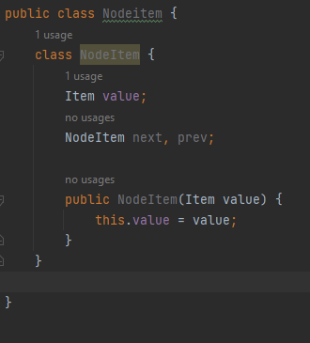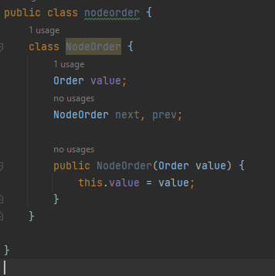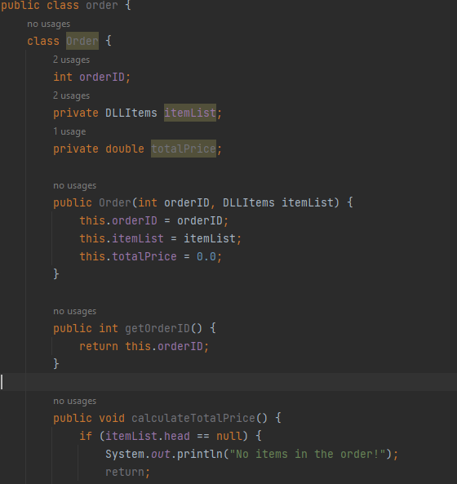

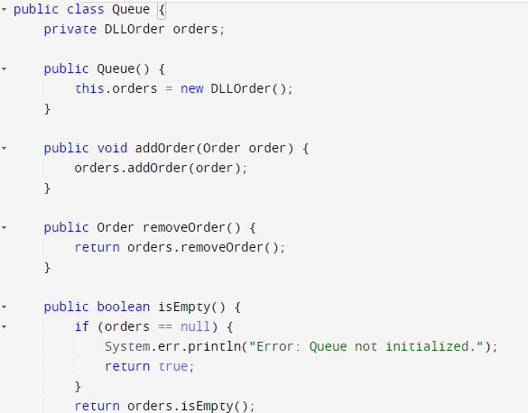

1:3

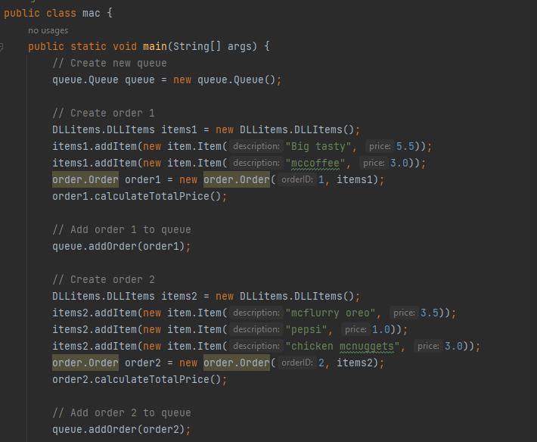

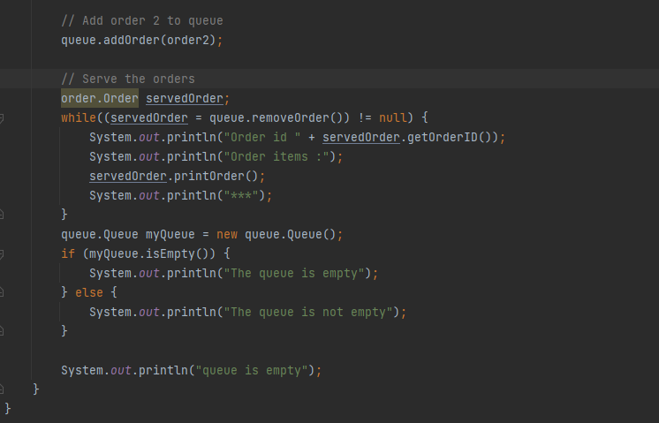

1:4

Here's an illustration to demonstrate how the queue handles orders in a First-In-First-Out (FIFO) manner:

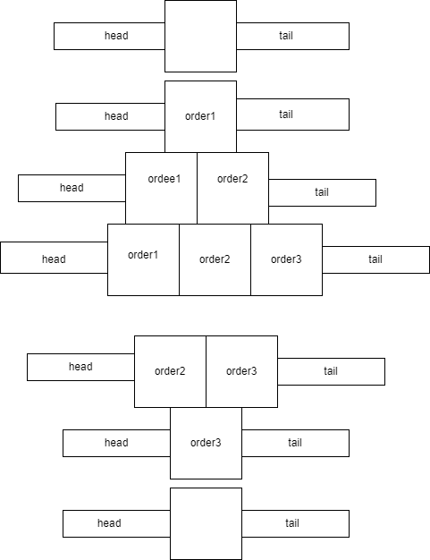

Two orders are added to a queue that is created by the mac class. The process then removes and processes each order, adding up the cost and outputting the order in.

Each order is represented by a rectangular box in the figure, which is labeled with the order ID and the goods in the order. From the front of the line to the back of the line, the orders are placed.

The queue is empty at first. The front of the queue designates the initial order that will be handled next, and as orders are added, they are placed at the back of the queue.

Following the FIFO principle, orders are taken from the front of the queue when they are withdrawn from the queue. Orders are processed, then removed from the front of the line, making room for the subsequent orders.

Let's look at an illustration:

The queue is empty at first.

Order Number One is added to the queue. It moves to the top of the line and is indicated by both the front and back of the line.

Order 2 is now on the waiting list. It is positioned at the end of the line.

Order 3 is now on the waiting list. It moves to the back of the line.

Order 1 gets moved to the back of the line so that it can be handled. Order 2 is now indicated at the head of the line.

Order 2 is handled after being taken out front. Order 3 moves to the front of the line.

Order 3 is then processed after being taken from the front. The line empties once more.

1:5

Implementing a queue class on an array and SLL has different implications in terms of space and time complexities, as well as trade-offs regarding queue operations and declassification. Here's a simplified overview:

1-Implementing a queue over an array

Enqueue Operation: Assuming the array has space, adding a member to the end of the array typically takes O(1) of time. However, if the array fills up, a resizing operation might be necessary, which would have a temporal complexity of O(n), where n is the number of array elements. The resizing operation entails copying the old elements into a new array with a larger capacity.

Dequeue Operation: Moving all the remaining elements to fill the empty space at the front of the array when an element is removed from the front of the array has an O(n) time complexity.

Space Complexity: The array-based version has an O(n) space complexity, where n is the queue's element count. To hold the elements, the array must allot a fixed-size block of memory.

2-Implementation of a queue over a singly-linked list (SLL)

Enqueue Operation: Because it requires modifying the final node's next pointer to point to the newly added node, adding an element to the end of the linked list has an O(1) time complexity.

Dequeue Operation: Because it requires changing the head pointer to point to the next node, removing an element from the front of the linked list has an O(1) time complexity.

Space Complexity: The SLL implementation has an O(n) space complexity, where n is the total number of elements in the queue. There must be a separate node for each element, which involves extra memory for the node pointers.

Trade-offs:

Since elements in an array-based system are stored in adjacent memory locations, random access to the elements is possible. When the array is full, it can necessitate resize operations, which could add time overhead.

Resizing operations are not necessary for SLL-based implementation because it can expand dynamically by adding new nodes. It works better when the queue's size is erratic or subject to change over time.

When compared to the theoretical time complexity of O(n) for dequeue in the array implementation, enqueue and dequeue operations are typically more effective in the SLL implementation, with a constant time complexity of O(1).
Due to the lack of additional memory needed for node pointers, array-based approach may use memory more sparingly. On the other hand, SLL implementation needs more memory for every node.

1:6:

, I can help define a stack specification and explain how a stack can handle the plate handling task.

Stack Requirements for a Plate Cabinet:

Adds a plate to the stack (in the cabinet) by pushing the item.

pop() takes the stack's top plate out of the cabinet and returns it.

peek(): Without deleting it, returns the plate currently at the top of the stack.

is_empty() determines whether or not the stack (cabinet) is empty.
Using a stack, we can handle the plate handling task as follows:

1-Create a blank stack to represent the plate cabinet at the beginning.

2-Use the push(item) method to elevate a fresh plate whenever one has to be added to the cabinet.

3-The pop() action can be used to remove and retrieve the top-most plate from the stack when McDonald's needs to use one.

4-They can use the is_empty() method to determine whether there are still any plates in the cabinet. The plates have all been consumed if the stack is empty.

5-The peek() technique can be used by MacDonalds to view the plate that is currently on top of the stack without changing it.

The Last-In-First-Out (LIFO) data structure assures that the last plate entered will be the first plate used. This is consistent with how McDonald's arranges the plates in the cabinet and removes the top plate when needed The way the stack behaves makes it possible to store and retrieve plates quickly When a plate is needed, the top plate is accessible and taken out of the stack. New plates are added by placing them on top of the stack. This is similar to how McDonald's manages its plate supply, with the most recent additions being easily accessible for usage The robot can manage the plate cabinet easily by using a stack and adhering to the specified stack procedures. The stack offers a straightforward and efficient way to handle the LIFO plate handling requirement.

Task2:

2:1:
I agree that ADTs serve as a foundation for object-oriented programming (OOP). Here's my justification:

Encapsulation and Information Hiding: As fundamental tenets of OOP, encapsulation and information hiding are inherent to ADTs. ADTs isolate internal information from access by encapsulating data and activity under a clearly defined interface. ADTs create a distinct separation between the interface and the internal workings by specifying operations to manipulate the data while abstracting away the implementation. This is consistent with the OOP ideas of information hiding and encapsulation.

ADTs encourage abstraction by giving a high-level overview of the data and operations without disclosing the implementation specifics. ADT users engage with the abstract interface, concentrating on the function of the data structure rather than its implementation. Modularity, code reuse, and simpler understanding of complicated systems are made possible by this abstraction and are essential components of OOP.

Even while ADTs may not explicitly mention inheritance or polymorphism, these concepts can be utilized as building blocks to construct more intricate object-oriented systems. Utilizing the concepts of inheritance, ADTs can act as the base types from which derived classes inherit and expand functionality. ADTs can also be used polymorphically, which enables the easy interchange of several ADT interface implementations.

Object-Oriented Design: ADTs offer a systematic method for developing complicated systems in accordance with OOP concepts. Through the grouping of related data and operations into coherent units, they make it possible to write reusable, modular, and maintainable code. The goals of OOP are aligned with the emphasis on abstraction, encapsulation, and information hiding in ADTs, which makes it easier to design and create object-oriented systems.

2:2:

I can explain the advantages of encapsulation and information hiding in the context of the Queue Abstract Data Type (ADT) and how it can be represented using a class diagram.

1-Encapsulation: A key component of object-oriented programming (OOP) is encapsulation, which involves grouping data and operations into classes and restricting access to an object's internal state. The benefits of encapsulation for a Queue ADT include the following.

advantages:

Data protection: Encapsulation makes sure that a Queue object's internal data is shielded from outside access. Only the defined Queue class methods can be used to read and modify the data. This safeguards the data's integrity and stops illegal alterations.

Modularity of the code: Encapsulation enables the Queue class to be created and maintained separately from other software components. The code that uses the Queue object is unaffected by changes to the internal implementation details of the Queue. This encourages modularity in coding and makes maintenance easier.

2-Information Hiding: Information hiding emphasizes that the internal implementation details of a class should be kept secret from the class's users, complementing encapsulation. It promotes a distinct division between a class's internal interface and public interface.

workings. The Queue ADT gains from information hiding in the following ways:

Abstraction: The Queue class is able to give a simple and clear interface by masking the complexity of the internal activities. Users of the Queue need simply comprehend and use the class's public methods; they don't need to be concerned with the specifics of their implementation. This makes it easier to use the Queue ADT

Information concealing safeguards the class from outside intervention and misuse by hiding the internal information about the Queue. It makes it possible to alter or improve the implementation without having an impact on user behavior. As a result, security and stability are improved because users are protected from pointless complexity and potential mistakes.

Class Diagram Representation: In an object-oriented system, a class diagram shows the structure and connections between classes. A straightforward class diagram for the Queue ADT would typically contain a single class that represents the Queue itself.

2:3:

Here are three key benefits explained in a simple manner:

Modularity and Reusability:

A queue, for example, can be implemented as a standalone module that can be utilized in a variety of programs and systems. It becomes a reusable component by enclosing the functionality of a queue under its own implementation. This encourages modularity since it makes it simple to integrate the queue into many contexts without having any negative effects on the surrounding code. By enabling developers to use already existing and thoroughly verified queue solutions, modularity and reusability reduce development time and effort.

Clear Abstraction and Interface:

An independent data structure offers a distinct abstraction layer that divides the usage of the data structure from its internal operations. While obscuring the inner workings of implementation, it defines a clear interface for interacting with the data structure. This abstraction facilitates code clarity and makes it easier to use the data structure. Because they don't have to worry about how the queue is implemented, developers can concentrate on using the queue's methods and properties, which improves the code's general maintainability and readability.

Efficiency and Performance:

Independent data structures can be optimized for specific operations, leading to improved efficiency and performance. By designing a queue specifically tailored for the required operations (e.g., enqueue, dequeue), the implementation can be optimized to minimize time and space complexity. This results in faster and more efficient operations, allowing for the effective handling of large amounts of data or time-sensitive operations. Additionally, independent data structures can be optimized for specific use cases, considering factors such as memory usage, concurrency, or specialized algorithms, further enhancing their performance.

Task 3

3.1:

Here I consider the sorting techniques used in the example, merge sort and insertion sort, and analyze their time complexities:

1-Merge Sort:

Best case: In the best, average, and worst circumstances, the time complexity of merge sort is O(n log n). This indicates that as the input size (n) rises, the merge sort's running time grows at a rate of n times the logarithm of n. No of the order or shape of the input, it constantly performs well.

Merge sort accomplishes this temporal complexity by repeatedly breaking the input into smaller subarrays, sorting those subarrays, and merging the sorted subarrays back together. It is capable of sorting big input sizes effectively thanks to the divide-and-conquer technique.

2-Insertion Sort:

Best case: When the input is already sorted, insertion sort has an O(n) time complexity. In this instance, it functions best with the fewest comparisons and swaps possible.

Typical and worst scenarios: However, in both the average and worst instances, insertion sort has a time complexity of O(n2). This indicates that when the input size (n) grows, the insertion sort's running time grows at a quadratic rate. For larger input sizes, it becomes ineffective.

By continuously inserting members from the array's unsorted section into its sorted section, moving elements as appropriate, insertion sort is able to achieve this temporal complexity. This method necessitates numerous swaps and comparisons, which slows down performance for bigger input sizes.

Merge sort is often more effective than insertion sort, especially for bigger input sizes, according to the asymptotic analysis. Merge sort scales well and handles bigger datasets with ease thanks to its time complexity of O(n log n). Insertion sort's performance degrades quickly due to its time complexity of O(n2), which makes it less appropriate for larger inputs.

We may test these sorting methods on arrays of various forms (random, sorted, and reversed) and track their execution durations to compare how well they work. This will confirm the theoretical analysis offered by the asymptotic complexity and provide us with empirical proof of how they function in real-world settings.

asymptotic analysis:
how asymptotic analysis help us to do evaluation the algorithm

By examining how algorithms behave as the size of the input increases toward infinity, asymptotic analysis is a mathematical technique that helps in the evaluation of algorithms. It is essential for evaluating the effectiveness and performance traits of algorithms. Asymptotic analysis enables broad conclusions about algorithm efficiency that hold true for large inputs by focusing on the growth rate of algorithms rather than their absolute running times. The evaluation of algorithms is aided in several ways by this analysis. First of all, it makes it easier to compare the performance of many algorithms that address the same issue, enabling us to choose the more effective solution based on their time or space complexities. By determining the algorithm with the lowest complexity and ensuring the highest efficiency for a given problem and input size, it also aids in the selection of algorithms. Asymptotic analysis also helps in anticipating scalability, which is important for real-world settings as it allows us to forecast how an algorithm will behave as the size of the input rises. It also shows potential prospects for optimization, allowing us to concentrate on crucial areas for development. Finally, through informing choices about data structures, algorithmic approaches, and trade-offs between time and space complexity, asymptotic analysis directs algorithm creation and change. Although it offers helpful insights, it's crucial to take into account additional elements like hardware and implementation specifics for a precise performance assessment.

In another explain:

It enables us to compare the effectiveness of various algorithms that solve the same problem, allowing us to select the one that is the most effective based on their asymptotic complexity. Asymptotic analysis additionally enables us to forecast how an algorithm will scale as input size rises, assisting in evaluating the algorithm's applicability for real-world circumstances. By pointing out algorithms with fewer complexities, it directs algorithm selection to ensure maximum effectiveness. Additionally, by concentrating on crucial areas with high complexity, asymptotic analysis aids in locating optimization opportunities within algorithms. By directing the choice of appropriate data structures and approaches to reduce time and space complexities, it has an impact on algorithm design and change. Although asymptotic analysis offers a broad overview of algorithm performance, it should be complemented with empirical testing for a comprehensive evaluation of efficiency considering real-world factors.

3.2:

time complexity and space complexity are commonly used metrics for measuring the efficiency of sorting algorithms such as merge sort and insertion sort:

Time Complexity: Time complexity gauges how an algorithm's execution time increases with the size of the input. It aids in our comprehension of how the algorithm scales as the size of the input rises. Big O notation is typically used to indicate time complexity.
Merge Sort: In both the best and worst case scenarios, merge sort has a temporal complexity of O(n log n). As a result, the running time of merge sort grows at a rate of n times the logarithm of n as the input size (n) increases. By breaking the input input into smaller subarrays, sorting them recursively, and then merging them back together, merge sort is able to achieve this temporal complexity.
Insertion Sort: In both the average and worst case scenarios, insertion sort has a temporal complexity of O(n2). This indicates that the running time of insertion sort grows at a rate of n ^2 as the input size (n) increases. By repeatedly adding entries into an array's sorted section, insertion sort is able to achieve this time complexity.

Space Complexity: As the size of the input rises, an algorithm uses more memory or storage space, which is measured by an algorithm's space complexity. It aids in our comprehension of the amount of memory required to effectively perform the algorithm.

Merge Sort: In the worst situation, merge sort has a space complexity of O(n). Accordingly, the amount of memory needed for merge sort increases in direct proportion to the size of the input array. During the merging process, it stores temporary arrays in this extra memory.

Insertion Sort: The space complexity of insertion sort is O(1), or constant. As a result, insertion sort doesn't need any extra RAM that expands along with the input size. It uses the current array to complete all of its actions in real time.

We can compare the performances of the sorting algorithms by benchmarking them on arrays with various shapes (random, sorted, and reversed). The asymptotic analysis of time complexity provides us with information on how the algorithms will function with larger inputs. Merge Sort will generally be more efficient than Insertion Sort, especially for bigger input sizes, because Merge Sort has a better asymptotic complexity of O(n log n) compared to Insertion Sort's O(n2).

3.3:

Discuss the implementation, complexity, array sizes, various array shapes, and performance of merge sort and insertion sort, and compare the acquired results to the desired results.

1-Implementation:

Merge Sort: The array is split up into smaller subarrays, sorted recursively, and then merged back together. During the merging process, this implementation needs more RAM for temporary arrays.

Insertion Sort: During each iteration of the array, elements are compared and swapped to place them in the appropriate positions in the sorted section. There is no need for additional memory with this implementation.

2-Complexity:

Merge Sort: Merge sort is effective for handling huge input sizes because of its O(n log n) time complexity and O(n) space complexity. No of the input shape, its divide-and-conquer strategy assures a consistent performance.

Insertion Sort: Insertion sort has an O(1) space complexity and an O(n2) time complexity. Due to the quadratic time complexity, it performs worse for bigger input sizes.

3-Array Sizes

Merge Sort: With both small and big input sizes, merge sort performs well. Its O(n log n) time complexity guarantees effective sorting even for very huge arrays.

Insertion Sort: Insertion sort has a time complexity of O(n2), which makes it ideal for small input sizes but more inefficient for bigger arrays.

4-different array shapes

Merge Sort: The input shape has no bearing on merge sort. In spite of the array being random, sorted, or inverted, it still has an O(n log n) time complexity.

Insertion Sort: The input shape has a significant impact on how well Insertion Sort performs. When the array is already sorted, it performs best; when the array is flipped, it performs worst.

5-Evaluation of outcome:

Merge Sort: Merge sort is designed to give a consistently effective sorting algorithm, and it succeeds in doing so. It functions well with various array sizes and shapes, and the time complexity scales well for bigger inputs.

Insertion Sort: The goal of insertion sort is to produce a straightforward sorting algorithm that works with minimal input sizes or arrays that are virtually sorted. Due to its time complexity, it performs well in these situations but degrades with bigger inputs, as would be predicted.

You can assess the actual performances of merge sort and insertion sort and compare them to the desired results by benchmarking them on arrays of various sizes and shapes. The results should match up with the temporal complexity-based theoretical analysis. While insertion sort should perform better for smaller or nearly sorted arrays and worse for bigger or reversed arrays, merge sort should exhibit constant efficiency across various contexts.
Task 4:
The branches

{B2 B5}, {B5 C2}, {B1 B2}, {B1 C2}, {B1 B3}, {B1 B4}, {B4 B3}, {B4 C1}, {B3 C1}, {B3 B5}, {C1 C2}
Nodes | Distance | Edge
B2 | 0
b1 | ∞
b3 | ∞
b4 | ∞
b5 | ∞ 2 | B2-B5
c1 | ∞
c2 | ∞ 7 | B5-C2

There is no way from B1 =>C1

B2=> B5 => C2 {7}

{B1-B2}, {B1-B3}, {B1-B4}, {B1-C2}, {B4-C1}, {B4-B3}, {B3-C1}, {B3-B5}, {B2-B5}, {B5-C2}, {C1-C2}

Nodes | Distance | Edge
b1 | 0
b2 | ∞ 3 | B1-B2
b3 | ∞ 1 | B1-B3
b4 | ∞ 10 | B1-B4
b5 | ∞ 4 | B3-B5
c1 | ∞14 2 | B4-C1 -B3-C1
c2 | ∞ 0 | B1-C2

B1 => C2 {0}

B1 =>B3 =>C1 {2}

{B4-C1}, {B4-B3}, {B3-B5}, {B3-C1}, {B5-C2}, {C1-C2}, {B2-B5}, {B1-B2}, {B1-C2}, {B1-B3}, {B1-B4}

Nodes | Distance | Edge
B4 | 0
b1 | ∞
b2 | ∞
b3 | ∞ 1 | B4B3
b5 | ∞ 4 | B3B5
c1 | ∞ 4 2 | B4C1 B3C1
c2 | ∞ 9 4 | C1C2

B4 =>B3 => C1 {2}

B4 =>B3 =>C2 {4}

{B3 B5}, {B3 C1}, {C1 C2}, {B5 C2}, {B4 C1}, {B2 B5}, {B1 B2}, {B1 C2}, {B1 B3}, {B1 B4}, {B4 B3}

Nodes | Distance | Edge
B3 | 0
b1 | ∞
b2 | ∞
b4 | ∞
b5 | ∞ 3 | B3-B5
c1 | ∞ 1 | B3-C1
c2 | ∞ 3 | C1-C2

B3 => C1 {1}

B3 => C1 => C2 {3}

{B5-C2}, {B2-B5}, {B3-B5}, {B3-C1}, {B4-C1}, {B4-B3}, {B1-B4}, {B1-B3}, {B1-B2}, {B1-C2}, {C1-C2}
Nodes | Distance | Edge
B5 | 0
b1 | ∞
b2 | ∞
b3 | ∞
b4 | ∞
c1 | ∞
c2 | ∞ 5 | B5C2

I dont found any way from B5 => C1

I found many ways here B5 =>C2 {5}

Dijkstra Algorithm
Nodes | Distance | Parent
b1 | 0
b2 | ∞ 3 | B1
b3 | ∞ 1 | B1
b4 | ∞ 10 | B1
b5 | ∞ 4 | B3
c1 | ∞ 2 | B3
c2 | ∞ 0 | B1

B1 => B3 => C1 = {2}

B1 => C2 = {0}
Here is the places was visited B1, C2, B3, C1, B2, B5, B4
Nodes | Distance | Parent
b3 | 0
b1 | ∞
b2 | ∞
b4 | ∞
b5 | ∞ 3 | B3
c1 | ∞ 1 | B3
c2 | ∞ 3 | C1

B3 => C1 = {1}

B3 =>C1 => C2= {3}

Here is the places was visited B3, C1, C2, B5
Nodes | Distance | Parent
b5 | 0
b1 | ∞
b2 | ∞
b3 | ∞
b4 | ∞
c1 | ∞
c2 | ∞ 5 | B5

B5 => C2 = {5}

B5 =>C1 = There’s no way

Here is the places was visited B5, C2

Nodes | Distance | Parent
b2 | 0
b1 | ∞
b3 | ∞
b4 | ∞
b5 | ∞ 2 | B2
c1 | ∞
c2 | ∞ 7 | B5

B2 B5 C2 = {7}

B2 C1= There is No Way

Here is the places was visited B2, B5, B3, C2
Nodes | Distance | Parent
b4 | 0
b1 | ∞
b2 | ∞
b3 | ∞ 1 | B4
b5 | ∞ 4 | B3
c1 | ∞ 4 2 | B4 B3
c2 | ∞ 4 | C1

B4 => B3 => C1 = {2}

B4 =>C1 => C2 = {4}

Here is the places was visited B4, B3, C1, B5, C2

4:1:

Bellman-Ford Algorithm:

Even if a weighted graph has edges with negative weights, the Bellman-Ford algorithm can be used to determine the shortest route between a source vertex and all other vertices in the graph. The following is how each client can utilize it to find the MacDonald's location that is closest to them:
1. Set all other vertices' distances to infinity and the source vertex's distance to zero (the position of the delivery man).
2. For V-1 iterations, where V is the number of vertices in the graph, relax all the edges repeatedly.
3. If the distance to vertex u plus the edge's weight is less than the existing distance to vertex v for each edge (u, v), update the distance to v with the new shorter distance.
4. Taking into account any existent negative cycles, the shortest routes from the source vertex to other vertices will be identified after V-1 repetitions.
5. Follow the shortest route from each client to the source vertex, choosing the nearest MacDonald's branch based on the measured lengths.

Dijkstra's Algorithm:

In a non-negative weighted graph, the shortest path between a source vertex and all other vertices is determined using Dijkstra's algorithm. The following is how each client can utilize it to find the MacDonald's location that is closest to them:
1. Set all other vertices' distances to infinity and the source vertex's distance to zero (the position of the delivery man).
2. Make a priority queue, add the source vertex with a distance of 0, and then remove it.
3. Extract the vertex with the shortest distance while the priority queue is still full.
4. If the distance to u plus the weight of the edge (u, v) is less than the current distance to v for any given adjacent vertex v of the extracted vertex u, update the distance to v with the new shorter distance.
5. Keep doing this until each vertex has been seen.
6. Follow the shortest route from each client to the source vertex, choosing the nearest MacDonald's branch based on the measured lengths.
4:2:
The Bellman-Ford algorithm has an O(V * E) time complexity, where V denotes the number of vertices and E is the number of edges in the graph. The worst-case temporal complexity is O(V * E) since it relaxes all edges V-1 times. However, the process can end sooner and have a lower time complexity if there are no negative weight cycles.

The priority queue's data structure determines how time-consuming Dijkstra's algorithm is. The temporal complexity when using a binary heap is O((V + E)*logV), where V is the number of vertices and E is the number of edges. Each edge is only relaxed once during the process of retrieving the minimum element from the priority queue, which takes log V time.
The space complexity of the two techniques is identical, being O(V) for storing the distance values and O(V + E) for representing the graph.

For determining the shortest path in a network, Dijkstra's algorithm is typically more effective than Bellman-Ford's approach in terms of complexity. The Bellman-Ford algorithm, on the other hand, has the benefit of being able to handle graphs with negative weight edges and find negative weight cycles.
The right data structures to use for implementing these algorithms, such as priority queues for Dijkstra's algorithm, can have a big impact on how quickly they run.

Refernce :
GeeksforGeeks. (2019). What are the differences between Bellman Ford’s and Dijkstra’s algorithms? [online] Available at: https://www.geeksforgeeks.org/what-are-the-differences-between-bellman-fords-and-dijkstras-algorithms/.
shah, M. (2020). Dijkstra Algorithm: [online] GitHub. Available at: https://github.com/shahm888/Dijkstra-and-Bellman-Ford-Algorithms. [Accessed 13 Jun. 2023].
OpenGenus IQ: Computing Expertise & Legacy. (2021). Time & Space Complexity of Bellman Ford Algorithm. [online] Available at: https://iq.opengenus.org/time-and-space-complexity-of-bellman-ford-algorithm/.
Sryheni, S. (2020). Dijkstra’s vs Bellman-Ford Algorithm | Baeldung on Computer Science. [online] www.baeldung.com. Available at: https://www.baeldung.com/cs/dijkstra-vs-bellman-ford.

Reference
1-GeeksforGeeks. (2020). Merge Sort vs. Insertion Sort. [online] Available at: https://www.geeksforgeeks.org/merge-sort-vs-insertion-sort/.

2- www.interviewkickstart.com. (n.d.). Time and Space Complexities of all Sorting Algorithms. [online] Available at: https://www.interviewkickstart.com/learn/time-complexities-of-all-sorting-algorithms.

3- Khandelwal, V. (2021). What is Merge Sort Algorithm: How does it work and its Implementation | Simplilearn. [online] Simplilearn.com. Available at: https://www.simplilearn.com/tutorials/data-structure-tutorial/merge-sort-algorithm.
4- worldwidescience.org. (n.d.). insertion sort algorithm: Topics by WorldWideScience.org. [online] Available at: https://worldwidescience.org/topicpages/i/insertion+sort+algorithm.html.

5- www.angela1c.com. (n.d.). Benchmarking Sorting Algorithms in Python - angela1c.com. [online] Available at: https://www.angela1c.com/projects/cta_benchmarking/.

Reference
geeksforgeeks (2020). Time complexities of different data structures. [online] GeeksforGeeks. Available at: https://www.geeksforgeeks.org/time-complexities-of-different-data-structures/.

Udemy. (2021). Data Structures and Algorithms: Deep Dive Using Java. [online] Available at: https://www.udemy.com/course/data-structures-and-algorithms-deep-dive-using-java.

Coursera. (2021). Object Oriented Programming in Java. [online] Available at: https://www.coursera.org/learn/object-oriented-java
freeCodeCamp.org (2018). How to explain object-oriented programming concepts to a 6-year-old. [online] freeCodeCamp.org. Available at: https://www.freecodecamp.org/news/object-oriented-programming-concepts-21bb035f7260/.

Rehman, H. (2021). Data Structure and Its Advantages. [online] Medium. Available at: https://medium.com/@haseeb26.07/data-structure-and-its-advantages-3e9c2514c9c8.

Plagiarism
Plagiarism is a particular form of cheating. Plagiarism must be avoided at all costs and students who break the rules, however innocently, may be penalised. It is your responsibility to ensure that you understand correct referencing practices. As a university level student, you are expected to use appropriate references throughout and keep carefully detailed notes of all your sources of materials for material you have used in your work, including any material downloaded from the Internet. Please consult the relevant unit lecturer or your course tutor if you need any further advice.
Student Declaration
Student declaration
I certify that the assignment submission is entirely my own work and I fully understand the consequences of plagiarism. I understand that making a false declaration is a form of malpractice.

Student signature: :adel shurab Date:

